
A10
Sreenidhi Institute of Science and Technology
(An Autonomous Institution)
Code No: 101MA01/111MA01
B. TECH. I – Year I – Semester Examinations, December 2015 (Supplementary)
ENGINEERING MATHEMATICS – I (Common to All Except-BT)

Time: 3 Hours Max. Marks: 70

Note: No additional answer sheets will be provided.

Part - A
Max.Marks:20

Answer all QUESTIONS. EACH QUESTION CARRIES 2 MARKS.
- Find the value of k when the inverse of 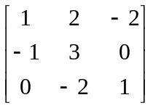 is 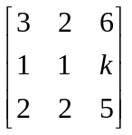

- Find the characteristic values of the matrix 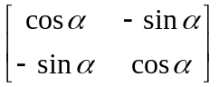
- Evaluate 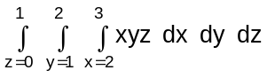.
- Determine the nature of the series 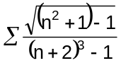

- Show that the set of vectors x₁=(1,1,0); x₂=(0,1,1) and x₃=(1,0,1) are linearly independent.
- Prove that the Eigenvalues of Diagonal matrix are diagonal elements.
- Evaluate the double integral 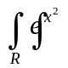dxdy, R : 2y≤x≤2 and 0≤y≤1.
- Define spectrum of A and spectral radius of A with an example.
- Change the order of integration to evaluate 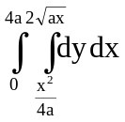.
- Evaluate 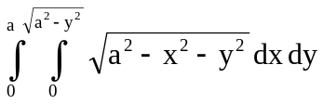.
Part – B
Max.Marks:50
ANSWER ANY FIVE QUESTIONS. EACH QUESTION CARRIES 10 MARKS.
- a) Show that the system
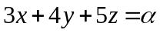
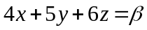
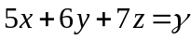
is consistent only when α, β and γ are in A.P.
- Find the rank of the matrix by converting the following matrix 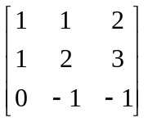
into normal form.

- a) Determine the characteristic roots and vectors of 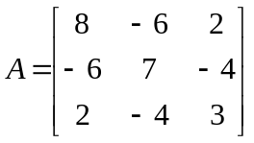 (6M)
- If 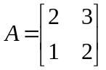, express A⁴ in powers of A. (4M)

- Reduce the quadratic form 3x²+5y²+3z²-2yz+2xz-2xy to canonical form.

- a) Test the convergence of the series
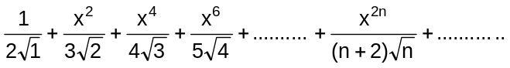.

b) If f(x)=sin⁻¹(x), 0<a<b<1, use mean value theorem to prove that 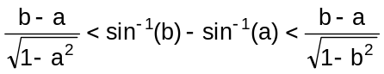.
5. a) Change the order of integration to evaluate the integral.
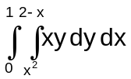
b) Evaluate 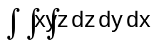over the volume enclosed by three co - ordinate plane and the plane x+y+z=1.
6. a) Reduce the following matrices into Echelon form and find its rank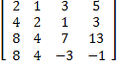.
b) Solve the following system of equations using Gauss elimination method & if possible find the solutions
x + y + 2z = 4, 2x –y +3z =9, 3x-y-z = 2.
7. a) If ρ₁ and ρ₂ are the radii of curvature at the ends of a focal chord of the parabola y²=4ax, then show that 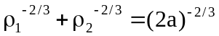.
b) Find the envelope of system of concentric and coaxial ellipses of constant area.
8. a) Evaluate 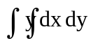, where R is the region bounded by the parabolas y²=4x and x²=4y.
b) Evaluate 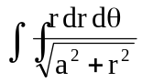over one loop of the lemniscate r²=a²cos2θ
-- 00 -- 00 –

